

ITI project

Under supervision of Dr. Hamdy Emad



**Team’s members:**

* Nour Elden Mahmoud Mohamed

Works on:

* Create Domain Model (actor, movie, producer, cinema) and the AppDbContext.
* Create Index View Page for each Domain Model like (actor, movie, producer, cinema), that display the List of each model
* Create The Adding page for (actor, movie, producer, cinema) with implementation of this Adding future
* Add the movie Details page
* Nareman Anis Sabry Hassan Areman

Works on:

* Create The Update page for (actor, movie, producer, cinema) with implementation of this update future
* Create The Delete page for (actor, movie, producer, cinema) with implementation of this Delete future
* Abdelrahman Ahmed

Works on:

**SUMMARY:**

The goal of our project is to develop a website that allows users to create accounts for seamless access to cinema services. Users will be able to reserve seats in various cinemas and obtain detailed information about films, including insights about the actors and producers involved. This platform aims to enhance the movie-going experience by providing users with convenient features and comprehensive film data and it allows the developers to add, edit or delete data about movies, actors and cinemas.

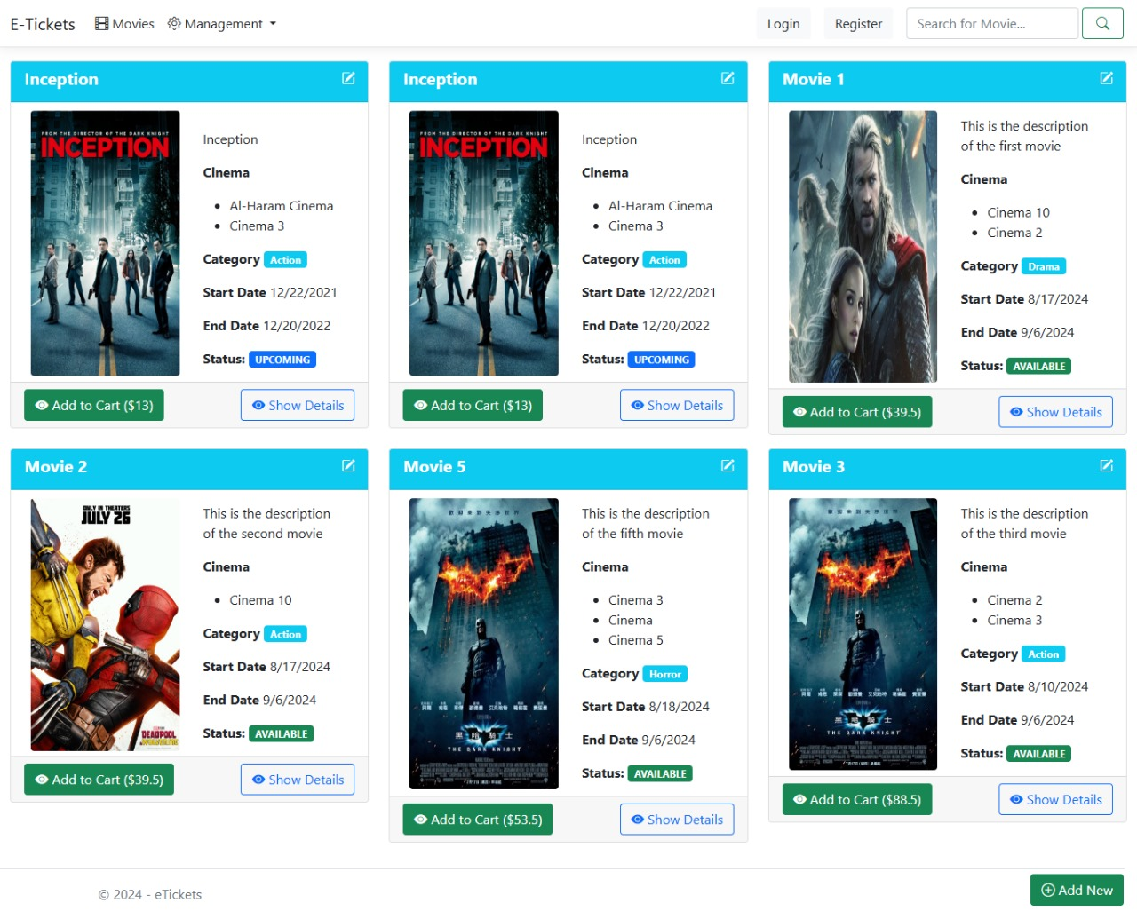

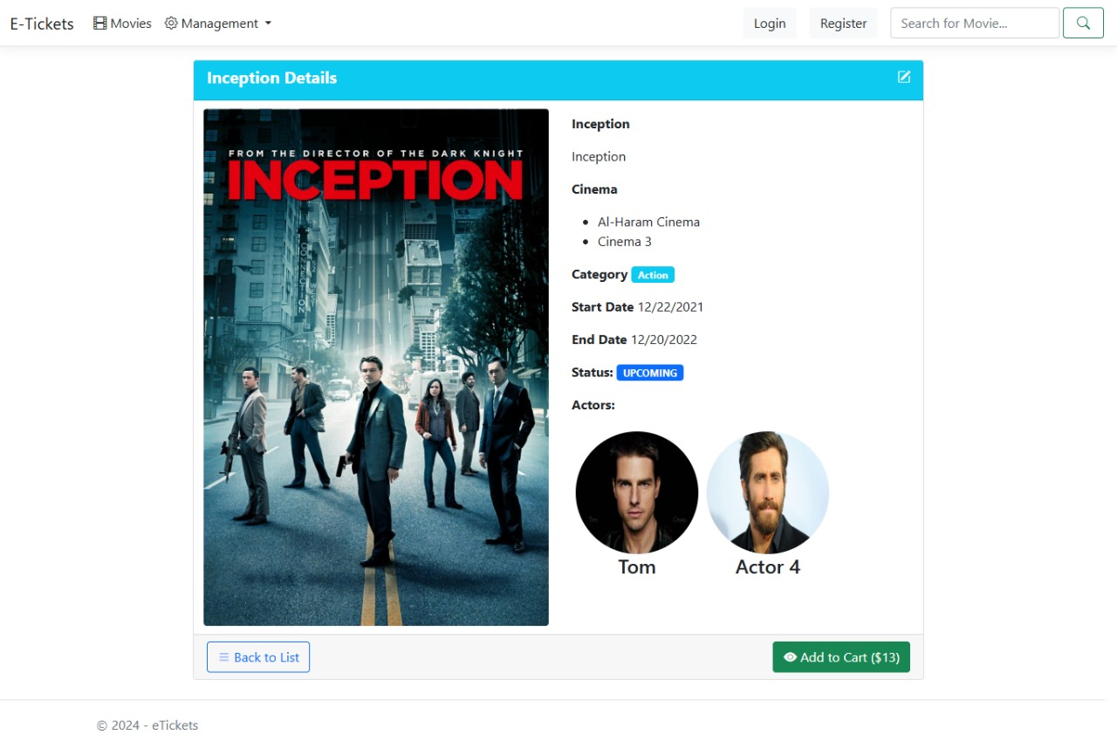

**Overview on project features:**

**1-resgistration feature:**

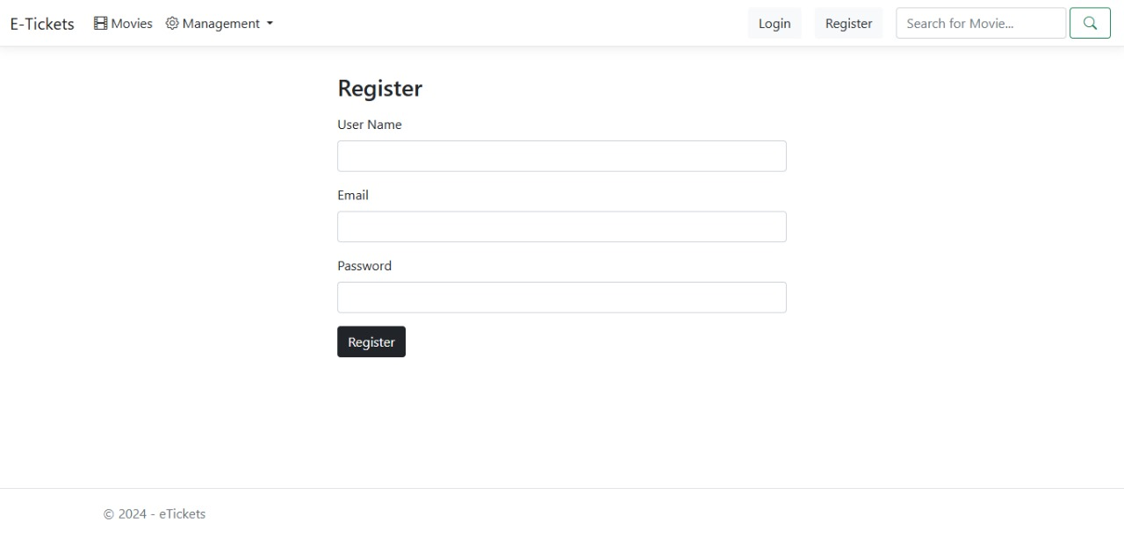

**2-login feature:**

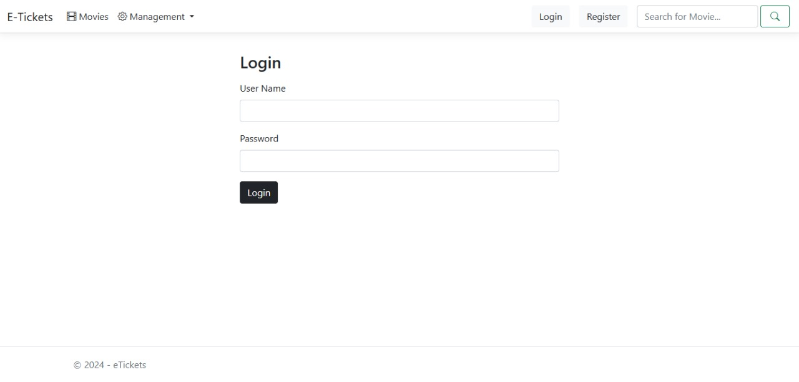

**3-adding features:**

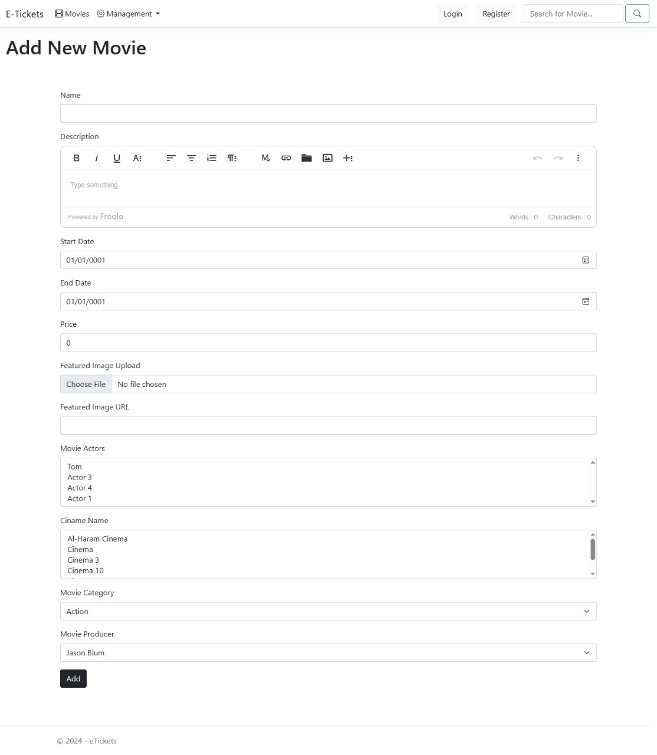

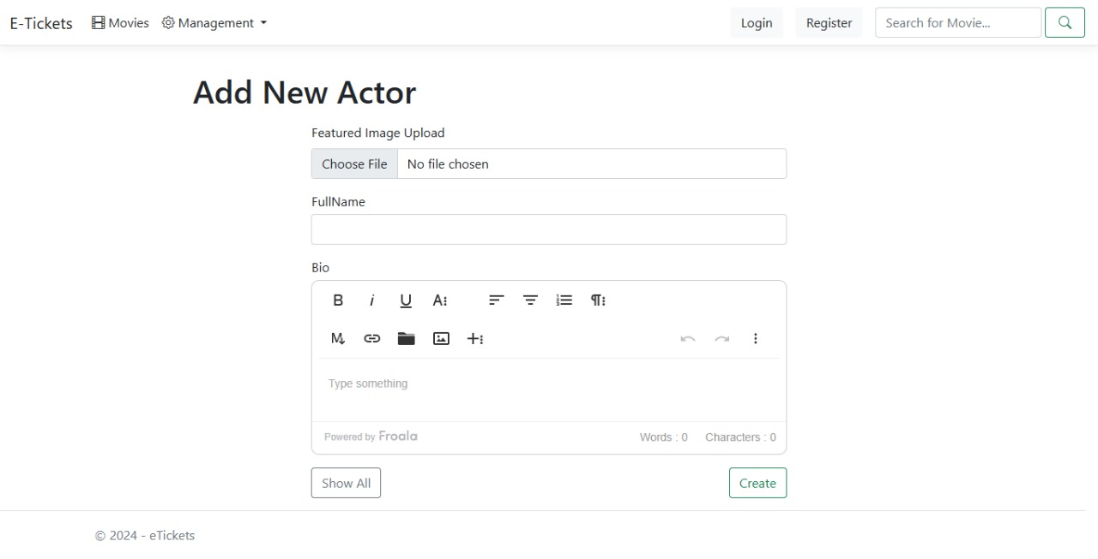

**4-editing and details features:**

